Rural Cultivation and Atmospheric Emulation Application (RCAEA)

***User Guide***

|  |  |
| --- | --- |
| **Authors:** | Al Al-Mohaiminul Islam Khan |
|  | Mihail Hadzhinikolov |
|  | Raima Khan |
|  | Richard Dyer |
|  | Tsanko Hadzhiev |
|  | Zisis Damianidis |
|  |  |
|  |  |
| **Creation Date:** | 19/01/2017 |
| **Last Revised:** | 19/01/2017 |
| **Group Name:** | Tanks & Co.™ |
| **Version:** | 1.0 |

Table of Contents

Introduction 3

Application Interface 3

Options Details 4

Main Functions Tutorials and Examples 5

Adding and Removing Crops 5

Choosing Additional Properties 5

Running a Simulation 5

Saving and Loading a Simulation 5

Troubleshooting 5

Index 5

# Introduction

This document is intended to give assistance to users who are utilizing the Rural Cultivation and Atmospheric Emulation Application (RCAEA). The user guide will contain both a written tutorial about the main functions of the RCAEA with associated images, as well as a troubleshooting section detailing possible errors or problems that may occur, along with their solutions. At the end of the document there will be an index section containing terminology that the user might not me familiar with.

# Application Interface

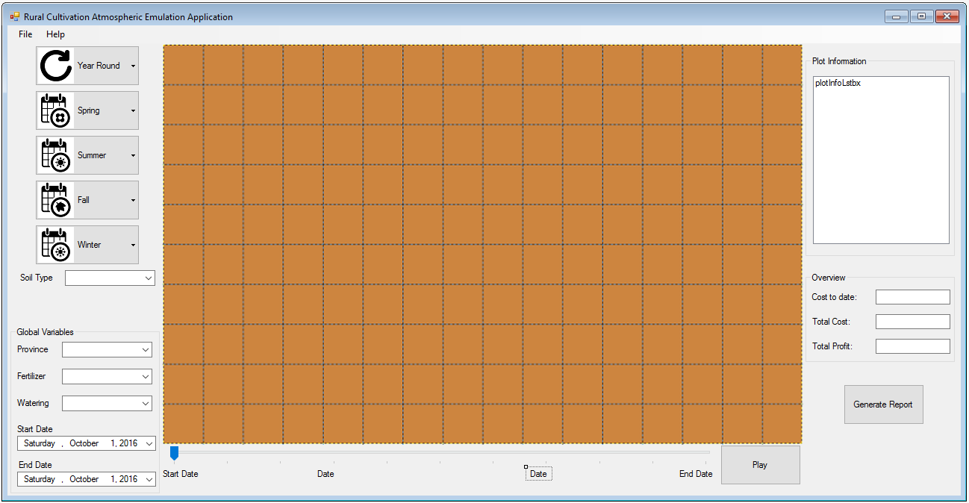

## Options Details

|  |  |
| --- | --- |
| **Interface Option** | **Description** |
| https://lh5.googleusercontent.com/atPl_EuvMpY15fr-JuPPopKYZFO9YwhmWYl9lx7tb0hpfPd04yeLYDloq5EIqEllAfWNvIJp-mUXTKK44Nea7wuOhsMM6EXte7v44M6ShSbH0Wnvb-8GpiCvCPhvuzrrqiSx3u3Z4pBmrrBWpQ | This button will show a menu with a list of crops that can grow all year round. |
| https://lh6.googleusercontent.com/AW4FWXWj0PnQM8Vs6JF8Yf4y8oJXuaWBlvVUofpK0IL_BhQLBSDaPDIYGlQBhrVoO2cAIM938zcRiKfxvnN4cHR-N9wSwiDt57cs19vpz95bMHsHhS4LQdjceHS--jsP-ypGJWhltSxbAHEYBg | This button will show a menu with a list of crops that can grow in the spring season. |
| https://lh6.googleusercontent.com/Ylrvwgye2UwKctOJZUNAmqy8jtBEyQ1UyKhetlTdwpQQTNNikLfdJPZzHpq7n_Ezi862xKMuWFmfyADuSzNJVppLWoak__1tqvPoP21ku-zvIpqR1nAiSPmPwdljXPDupMm5Pido6rdgMRQEmg | This button will show a menu with a list of crops that can grow in the summer season. |
| https://lh6.googleusercontent.com/TULD6VJIoeBrc8FwVBc0FQWXypw_pDan31hTHagfJlhovv3hNEYyc6c2x37m3NG7bG8aZ9HEcwZUbm0qKnS0LZkqDmujazd69OerKDcIa2Ky_A__Kj8LV-hMxKUlhocBJUql-4P9lZGkvgfq6g | This button will show a menu with a list of crops that can grow in the autumn season. |
| https://lh3.googleusercontent.com/E4imJ3SVHReLJ0J9riVuGJv6MMRYKub1ScbAkBUKNI5Up00uD_FYg4Z1E8d7b38_JMdFTa80PG47vKMTAmrwXpXGPEZgiKWguwUfDeF-ruUcuLMybZln4op301dk5NMNG38lHXf2zIZQyQOdZQ | This button will show a menu with a list of crops that can grow in the winter season. |
|  | These squared pieces of land are the plots. On them, the user can add/remove and grow crops. |
|  | This is the menu bar located at top of the application. It contains the "File" and "Help" options. By selecting the File option, you can choose to "Save" or "Load" a simulation. |
| https://lh6.googleusercontent.com/5ZiXVZ6PZzS1SvOvztf9pNV_BcdXEfu9FEQGe2qRzC5yvEjJo7P_OkNWXXKoqPiHt8gZJQeEhqUrNLbVioqoNaw8ASkbmVVlb7PO6Kqf-jSaq2rDyhquE59JeHj4lLmj37i4PBnoI1N5nu2niA | "Soil type" is used to select the type of soil that will be applied to the plots. |
| https://lh4.googleusercontent.com/KkU3ZWJt6M0GxPUqRXKkYpRpHQ_Smhk4jnqCnLcXPw9NT_cFfu17hBaelGzJOVBGcbaGG8CLkmftHpuKRpfbuIh3LvyCutEfQ4FU8sTHNeT9WXExsVbslLoGBQKpZqjNoedMqAvRSyLpZfW99A | Global variables affect the whole simulation and all plots.  "Province" is used for selecting the location of the field within the confinements of the Netherlands. Every province will have different weather and soil properties.  "Fertilizer" is used for selecting how much fertilizer will be used during the run time of the simulation.  "Watering" is used for selecting how much water will be used during the run time of the simulation. |
| https://lh3.googleusercontent.com/h9UoMIK1rNPP7xfBkIbKRNtS9k3GVKnmcXfVXy041Ba2661AbEFRccDy74sYgknMZqj0cWOd2-A2bqHbUKItiulkbo-EV6jLx7acwAy-76htmjgYh5ngrxiUp2bsrqZTxm1B6pRz_DMr7IpVzA | These options will be used to set the start and end dates of the simulation. |
| https://lh3.googleusercontent.com/5aGjaqemTRqW8sV6OXYFYjyFT8LHnEFTMluPErjy1_K967lRrNDmi-kbBvwAzD8JVgWS1yDY4hKfhq_UFGEwfHEU8MlSqYtsgeKtMT-I4PWQGF6MYNdSkwSbmqQCGwzDL2H5jyCQ2VPbNmhTGQ | The "Overview" section of the interface displays the "Cost to date" , "Total Cost" and "Total Profit" of the current simulation which are used to keep track of the potential income from the crops. |
|  | This progress bar can be used to quickly slide across the timeline of the simulation. The start and end dates depend on the selected choices in the "Start Date" and "End Date" options. |
| https://lh4.googleusercontent.com/GDIpbQnIXPKtRMJRDE8HyRzY8PrqrmDWdSeLuIyNG90ZVRbtBbrfcTRj1BEL6BXePtR0Ao3OMRup-YxYajDBMsA7wPnwZxxq6yB3POt_oOVu2O42P8ggr7RoD0S9aH096tOp0c0DTu-SLZmDbg | The "Play" button starts the simulation. It will also act as the "Stop"/"Pause" button when the simulation is running. |
|  | The "Plot Information" panel displays the statistics of the currently selected plot . |
| https://lh4.googleusercontent.com/L6FvZbnWbngJ1hLLnO8swig4E96Ds-gGdAWOPn2BTlggbDjd8VQh_kJ_tgjj3xFMdoUvl2RyovZtAtoyGf-b4aq9Bs5p8ro0GE_wAs9db-J-nTqKJ1f6dfvE3YSNNjBReMG218sL5Sy57MB8Qg | This button will generate an overall report of the current simulation. |

# 

# Main Functions Tutorials and Examples

This section will help guide the user through the main functions of the RCAEA. The examples will cover the basic principles of using the application and once the user is familiar with it, he will be able to easily customise it further to suit his preference.

## Adding and Removing Crops

## Choosing Additional Properties

## Running a Simulation

## Saving and Loading a Simulation

# Troubleshooting

# Index

This part of the document will serve as an explanation of the terminology that will be used throughout the document the user may not be familiar with.

**Global Variable** – Indicates configurations that will affect every plot in the current simulation.

**Simulation** – In this document refers to the current cultivational project that is opened in the application interface.

**Troubleshooting** – A term used to describe the process of trying to deal with a problem or error that the user might encounter.